**Chemical Management System**

**Submitted By: Lashika Arunachalam**

**Date of Submission: 28-11-2022**

**Table of Contents**

**1.** **Description of Business System Summary:** 3

**2.** **Schema Representation:** 5

**2.1 Logical Schema** 5

**2.2 Physical Schema** 6

**3.** **Representation of Tables from the Server:** 7

**4.** **Demonstration of Business Scenario and small Analysis:** 13

# **Description of Business System Summary:**

* Chemical Management System is a model of manufacturing company starting from production planning to the sales.
* Starting from the production planning, manufacturing the materials, storing the materials in the warehouse, managing the sales and handling customer master data with financial records.
* It has 6 Major tables to cover business flow:
  + Planned order table: which is used to store the production planning for the materials.
  + Production order table: this stores the actual production details, planned order will be converted into production order.
  + Inventory details table: this table stores the availability of materials and delivery status.
  + Sales order details table: this table stores the sales order information which contains material, quantity, total amount and customer related details
  + Customer master table: this table to store the customer master data such as customer id, full name, GL account etc.,
  + Financial Information: this table stores the entire financial related transaction details for each sales order with respect to the customers.
* It covers the production planning, inventory management, sales overview, customer dashboard, financial dashboards.
* Production planning majorly covers business flow of planning the material production to actual manufacturing of the material.
* Inventory management: this part majorly covers the stock availability, specific consumption of material.
* Sales overview: this covers the detailed sales overview. Sales happened based on the customer, geo graphical location, sales happened during particular time period.
* Customer dashboard: this covers newly added customer insights, no of active customer, pending payment status for each customer,
* Financial information: displays the financial status of the overall company progress.

# **Schema Representation:**

# **Logical Schema**

Logical Schema is a diagrammatic representation of Entity Relationship in database. Entities are tables and Attributes are fields.

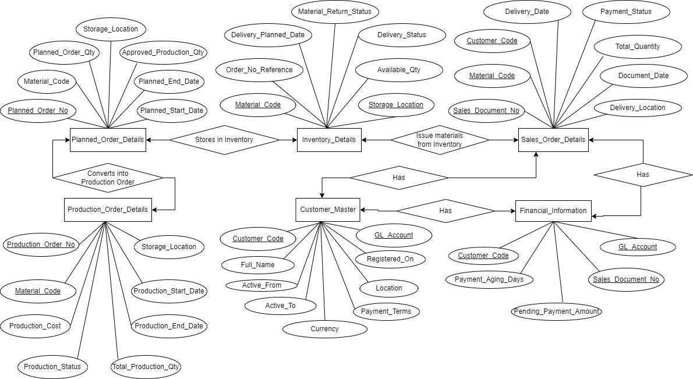

# **2.2 Physical Schema**

Physical Schema is a representation of a database at physical level and shows how data is stored in database.

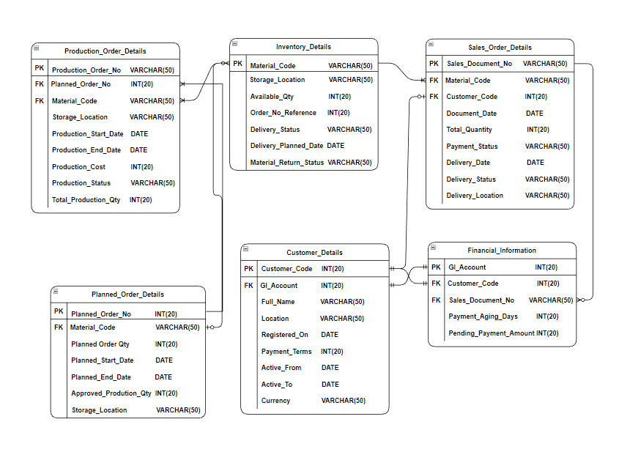

# **Representation of Tables from the Server:**

**Representation of tables:**

**Production_Order_Details**

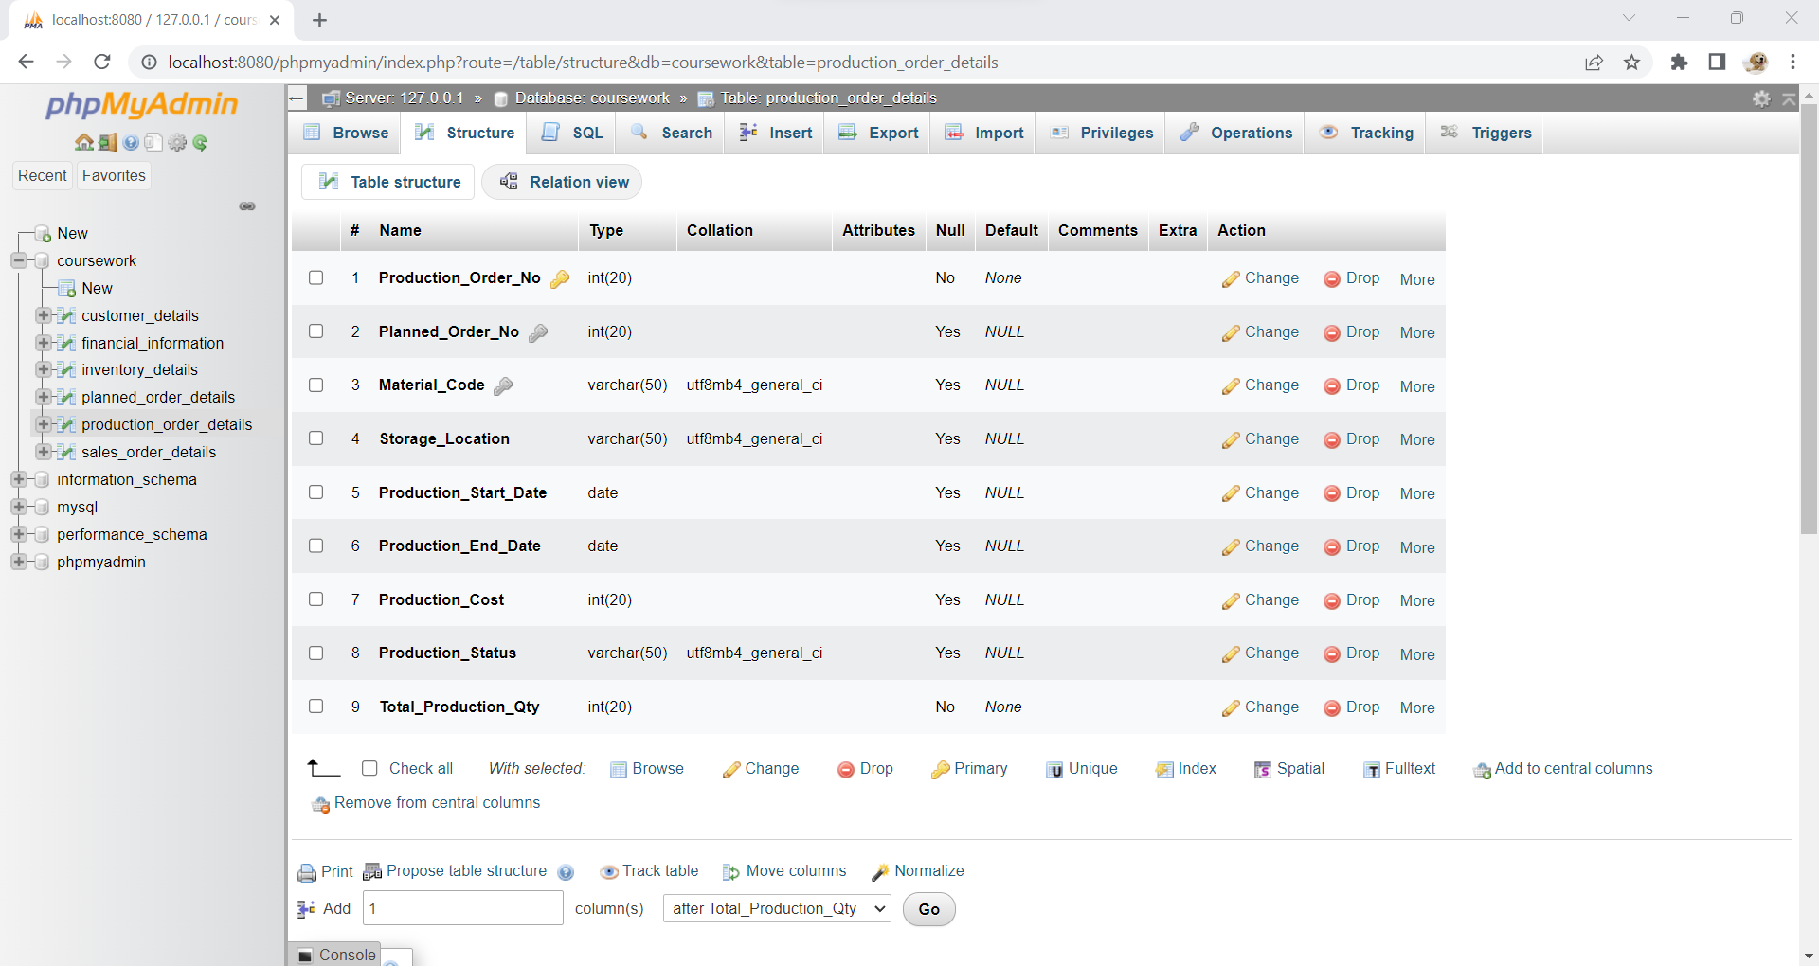

**Production_Order_Details (Populated with Data)**

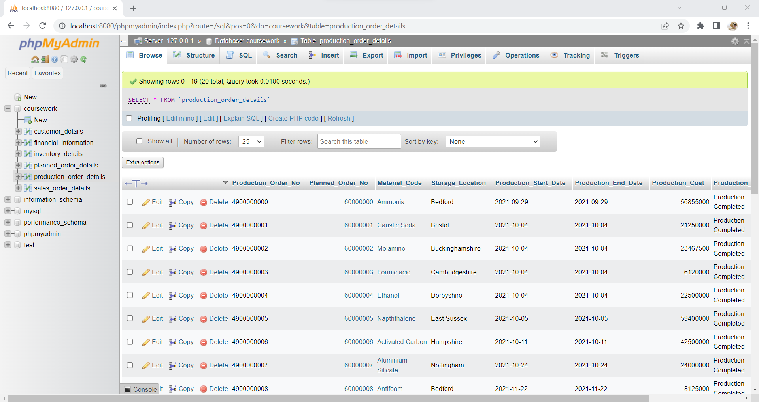

**Planned_Order_Details**

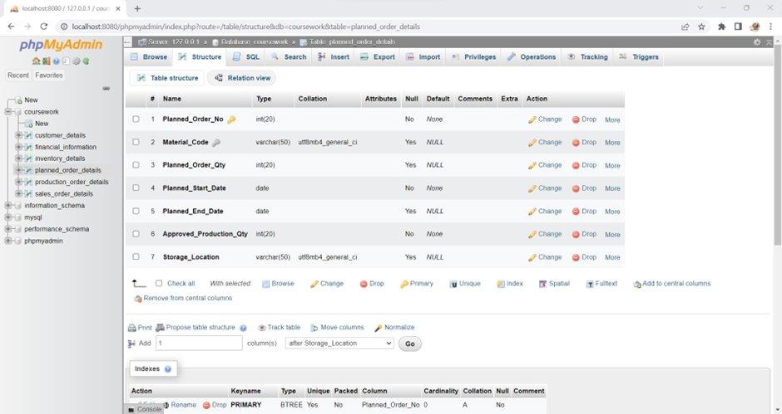

**Planned_Order_Details (Populated with Data)**

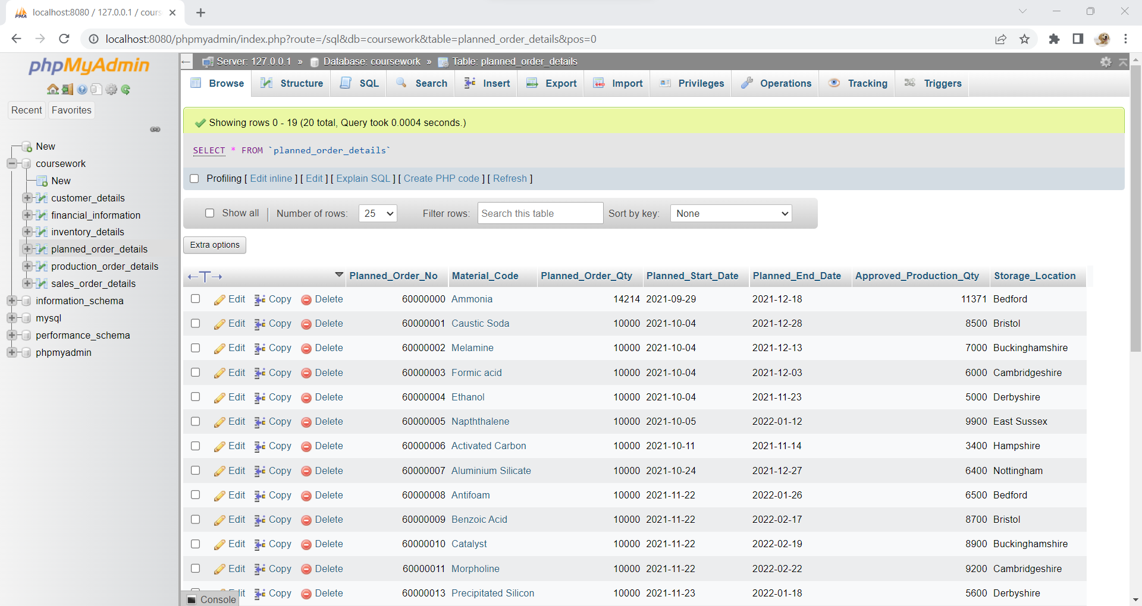

**Inventory_Details**

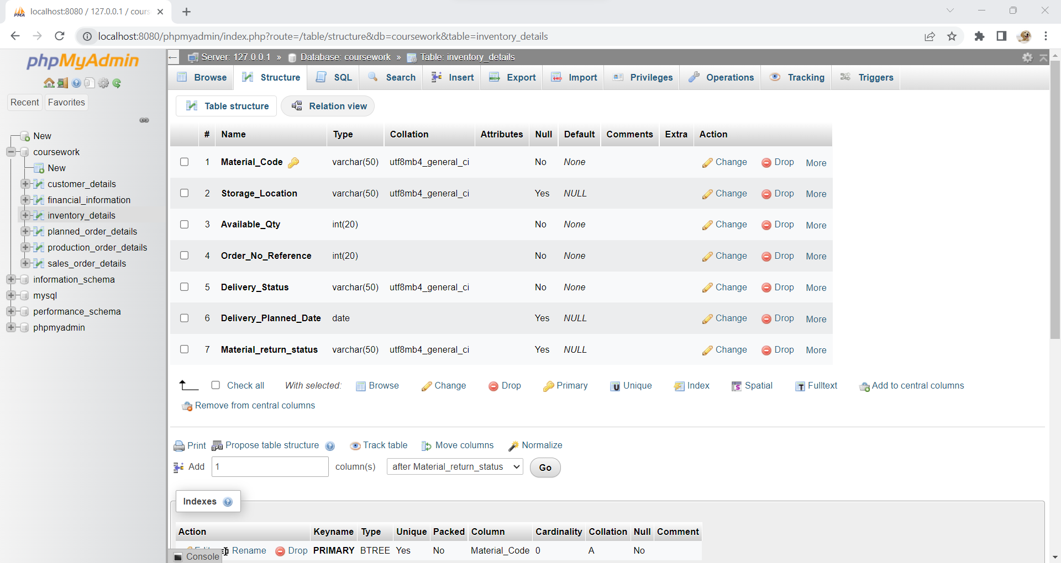

**Inventory_Details (Populated with Data)**

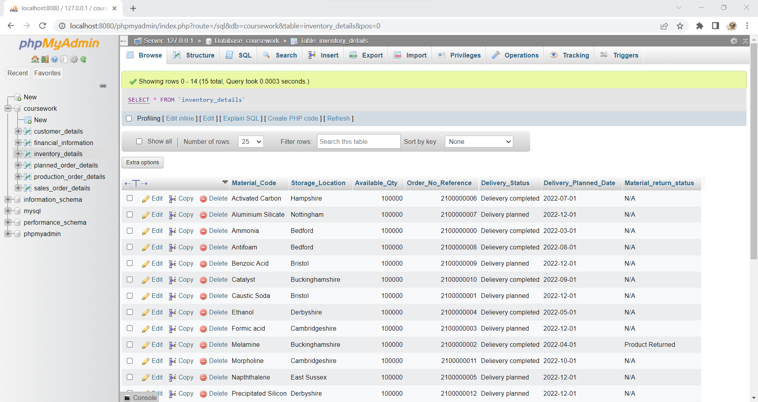

**Customer_Details**

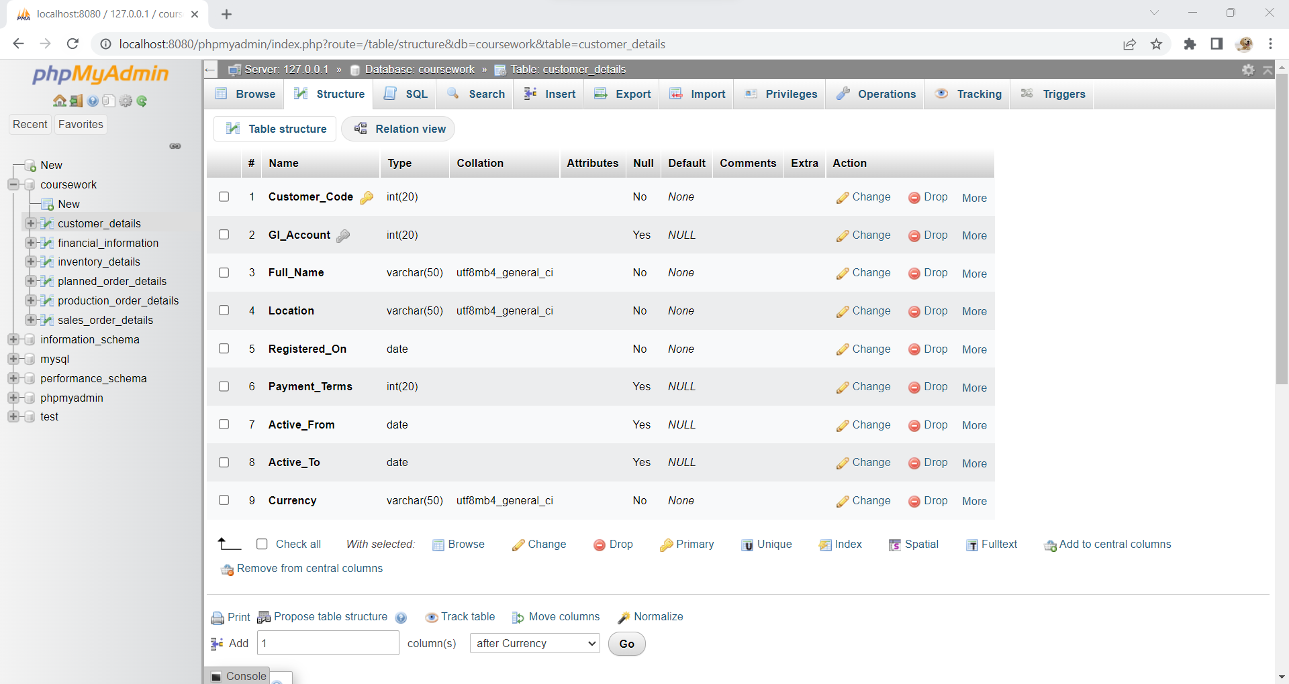

**Customer_Details (Populated with Data)**

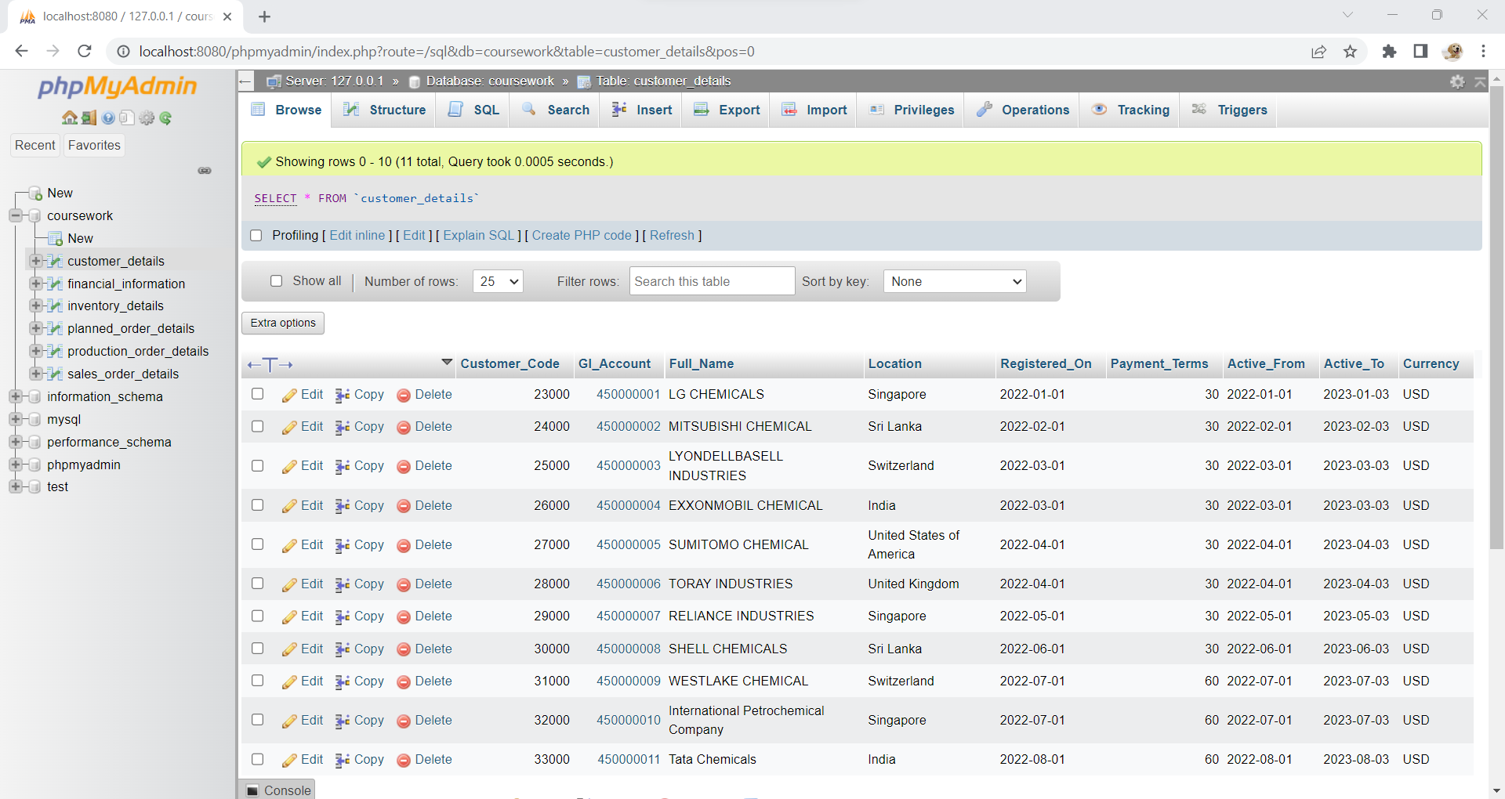

**Sales_Order_Details**

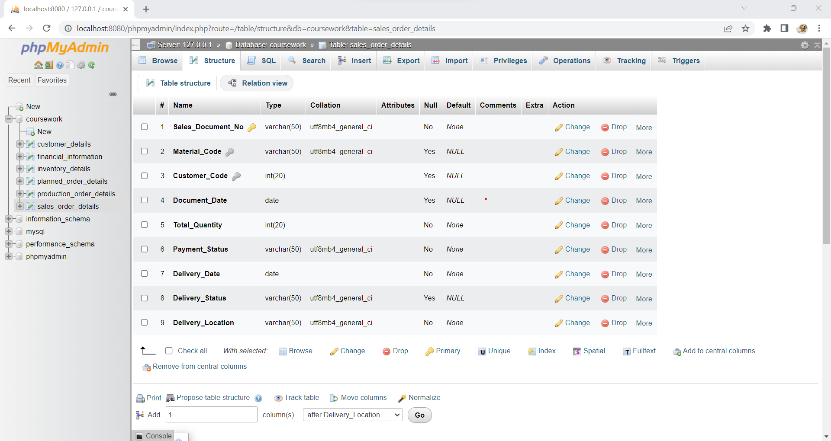

**Sales_Order_Details (Populated with Data)**

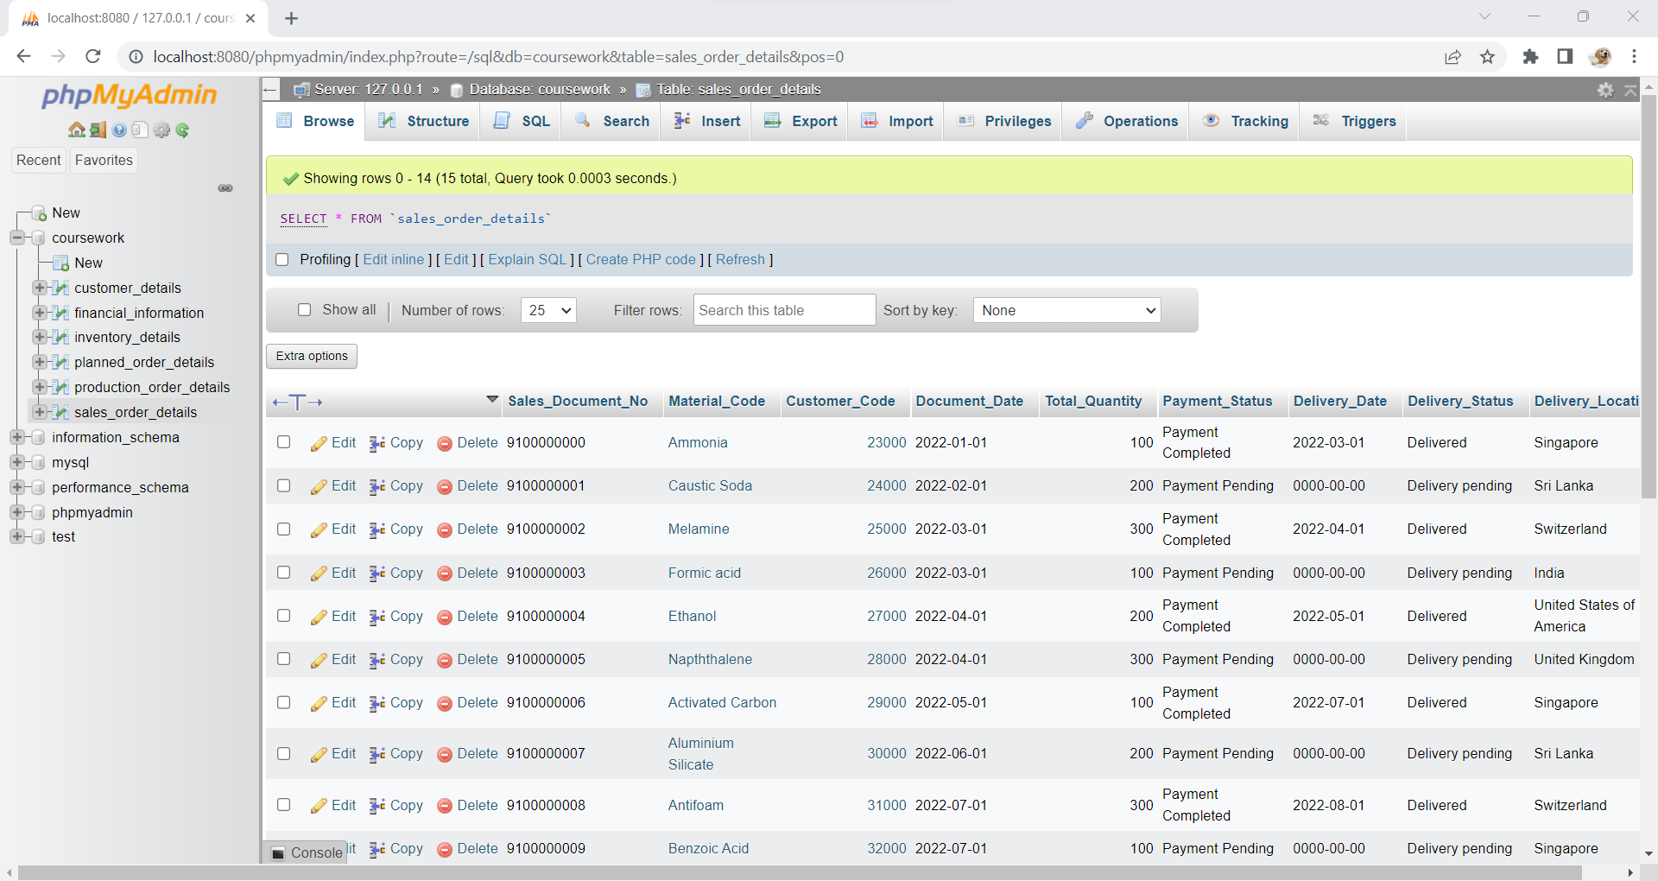

**Financial_Information**

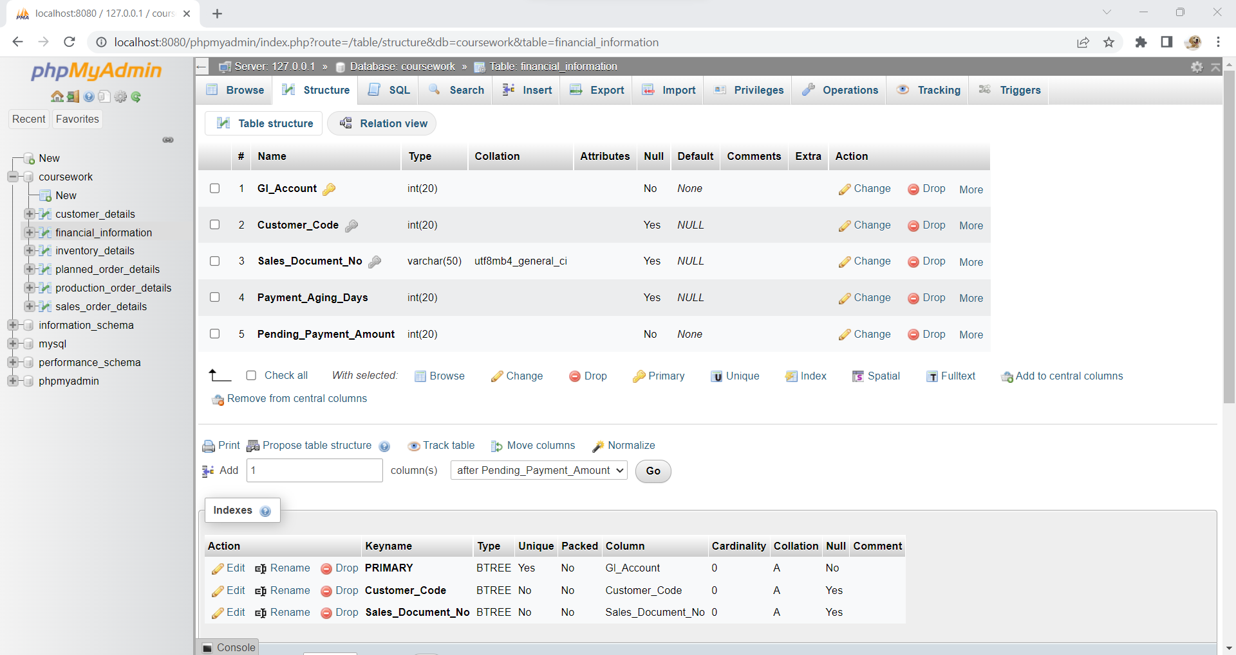

**Financial_Information (Populated with Data)**

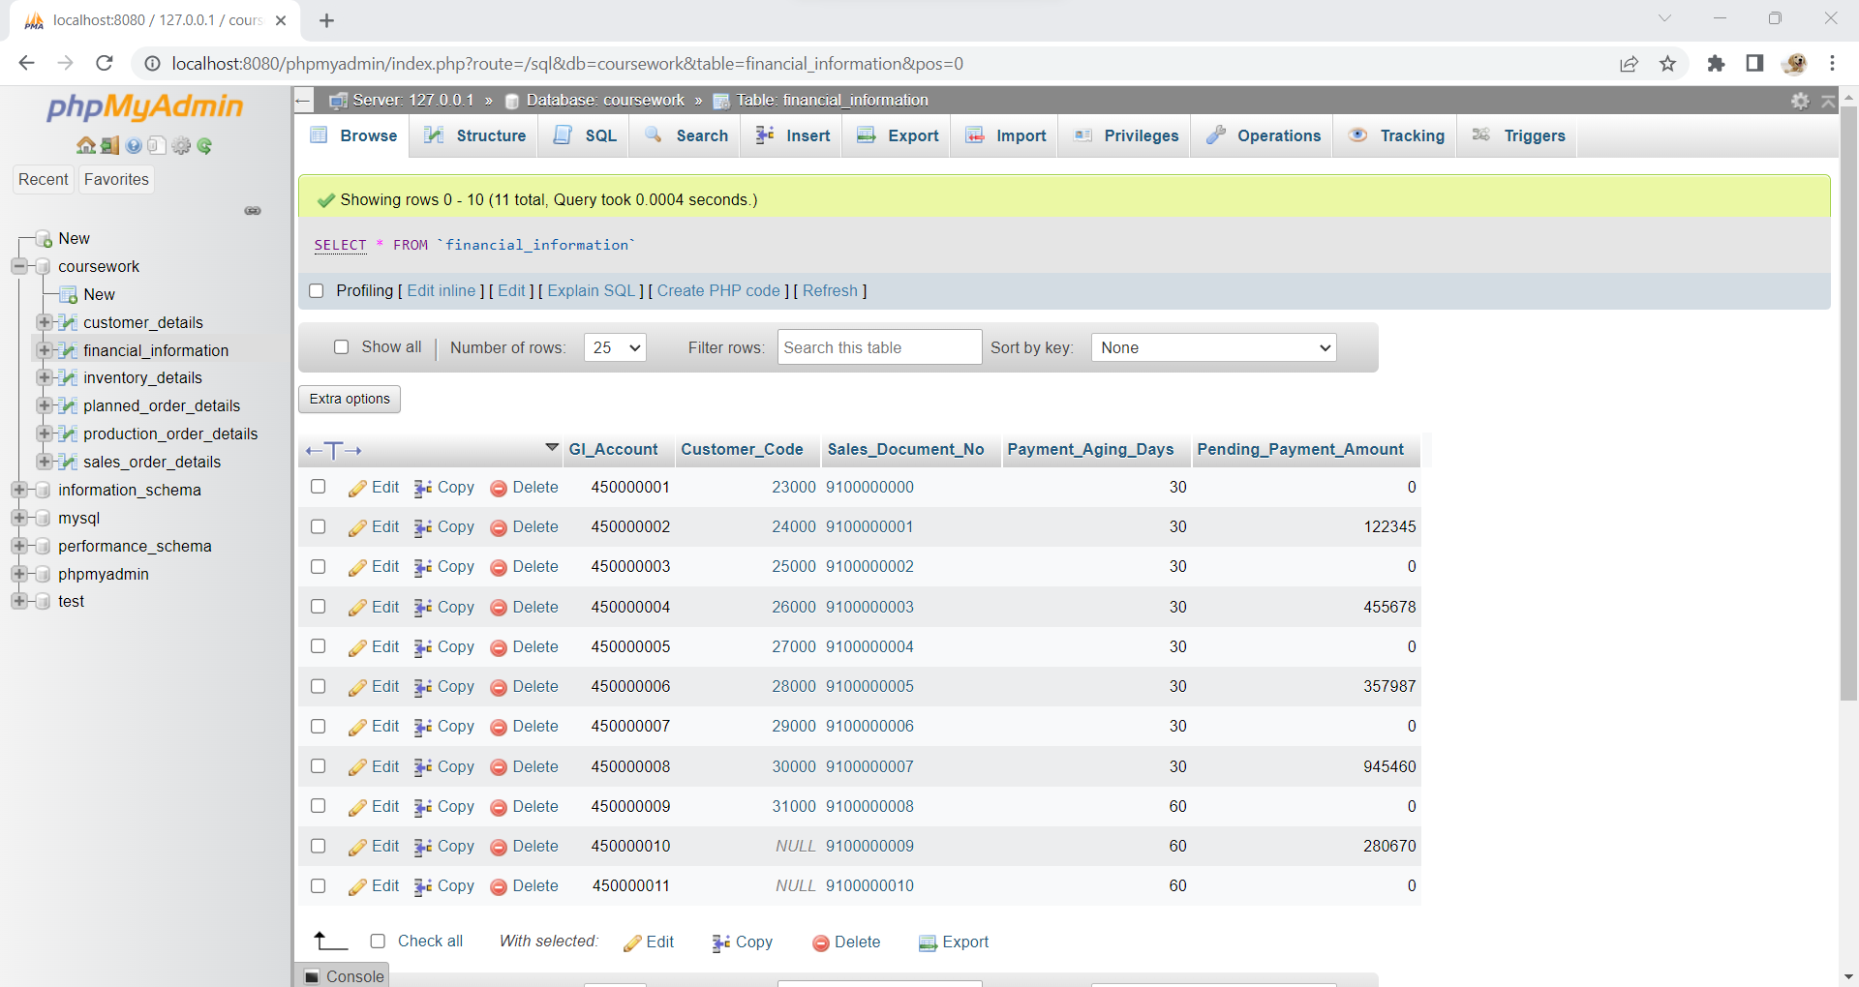

# **Demonstration of Business Scenario and small Analysis:**

**DQL:1**

Finding the Material_Code, Planned_Order_Qty and Percentage of the production for all the Material Code from production_order_details and planned_order_details.

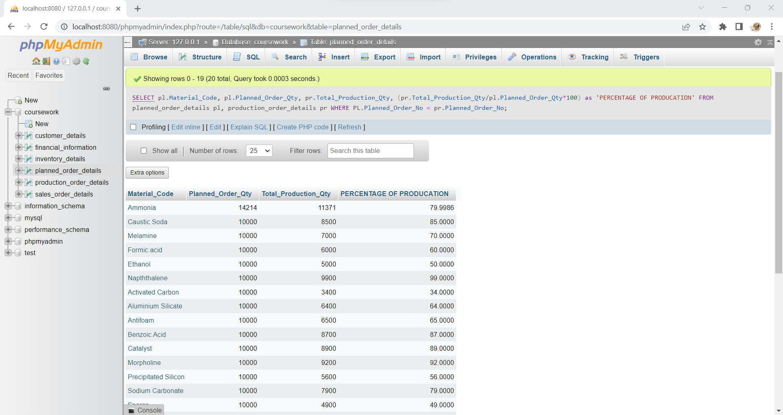

**Justification of DQL:1**

The query executed in the above operation is useful for the Chemical industry to find the percentage of the chemicals sold in the company which further helps them to start with the next set of production for sales.

**DQL:2**

Finding the Material_Code, Storage_Location, Available Quantity and Total Quantity for all the Material_Code from inventory_details and sales_order_details.

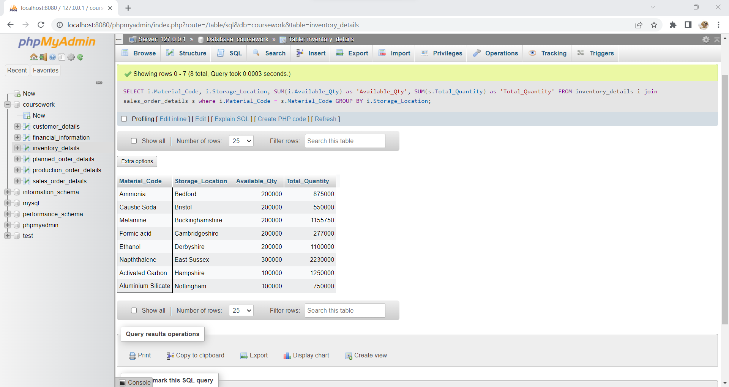

**Justification of DQL:2**

The query executed in the above operation useful for finding the total quantity sold and total available quantity in the company which helps them to take other set of the set of sales order if received.

**DQL:3**

Finding the Number of Active Users in the available years in customer_details.

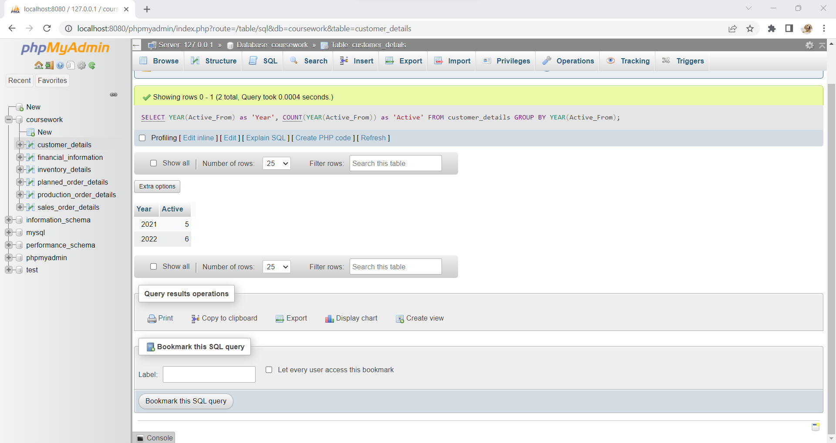

**Justification of DQL:3**

The query executed in the above operation useful to find the Active users in the available years which helps them to know whether to take any new sales if approached to avoid late delivery of items.

**DQL:4**

Finding the Sales orders who have pending amount and for how many days they didn’t pay the amount.

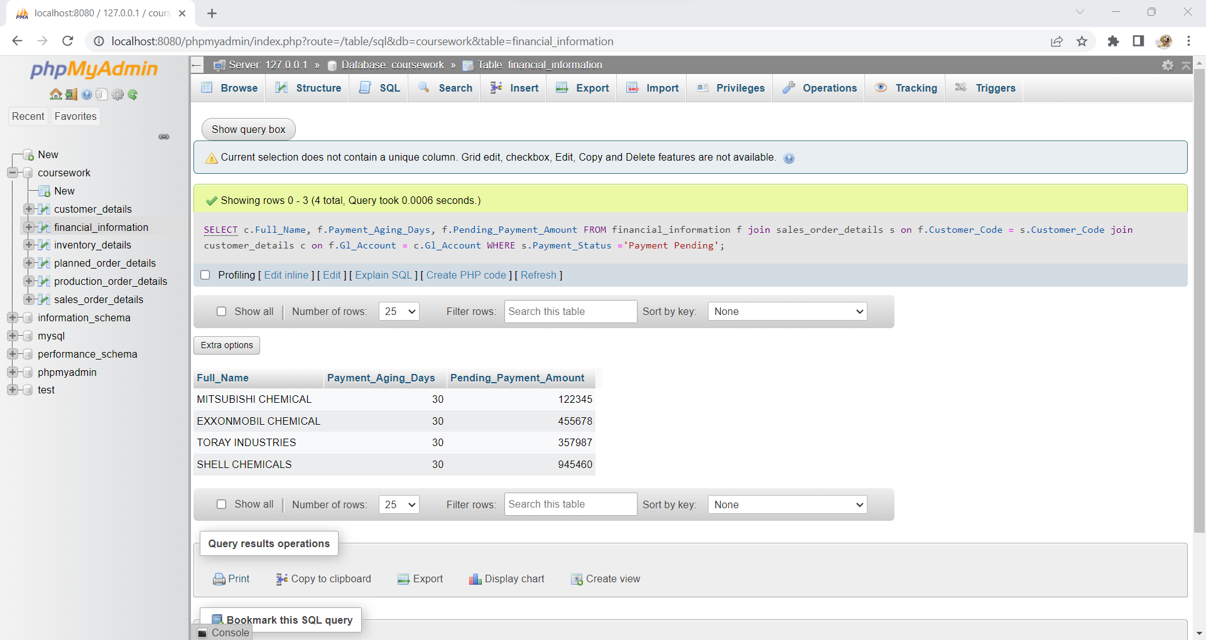

**Justification of DQL:4**

The query executed in the above operation helps the company to find the orders who didn’t pay their pending due and urge them to pay it before the delivery. In other way, this query helps to track their aging days.

**DQL:5**

Finding the Remaining Quantity of the material_code from production_order_details, planned_order_details and inventory_details.

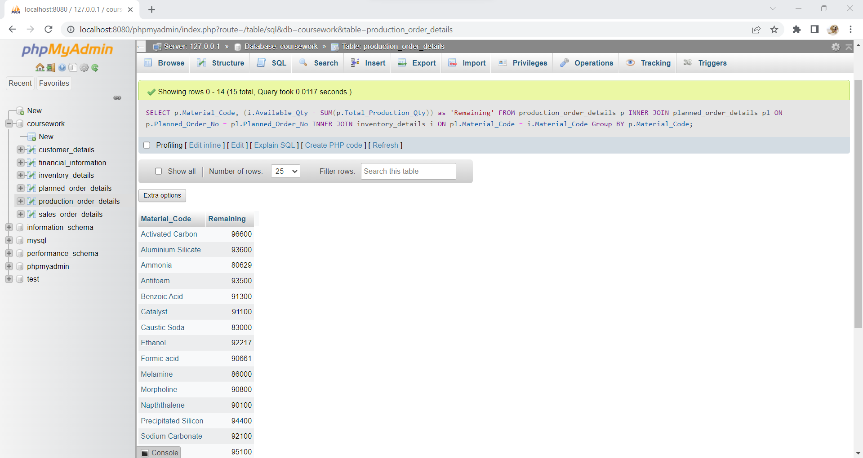

**Justification of DQL:5**

The query executed in the above operation helps the chemical company to know the quantity of materials in the stock which makes them ready to start the production if needed.

**DQL:6**

Finding the Delivery Pending materials and location from slaes_order_details.

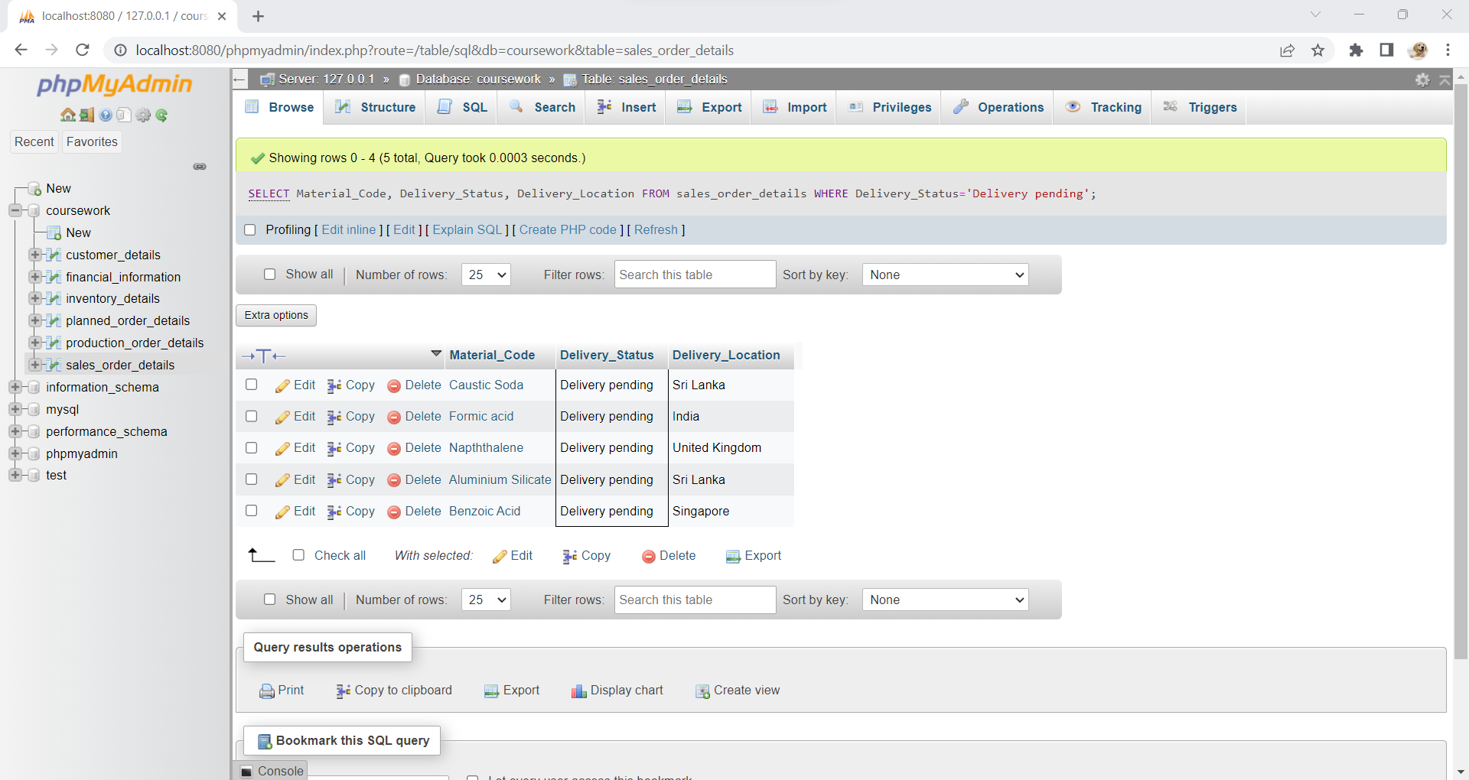

**Justification of DQL:6**

The query executed in the operation helps the company to know the orders which are pending for the delivery so that they can find out the reason for pending and deliver as soon as possible to avoid gaining black mark on the company.

**DQL:7**

Finding the product which got returned after delivery.

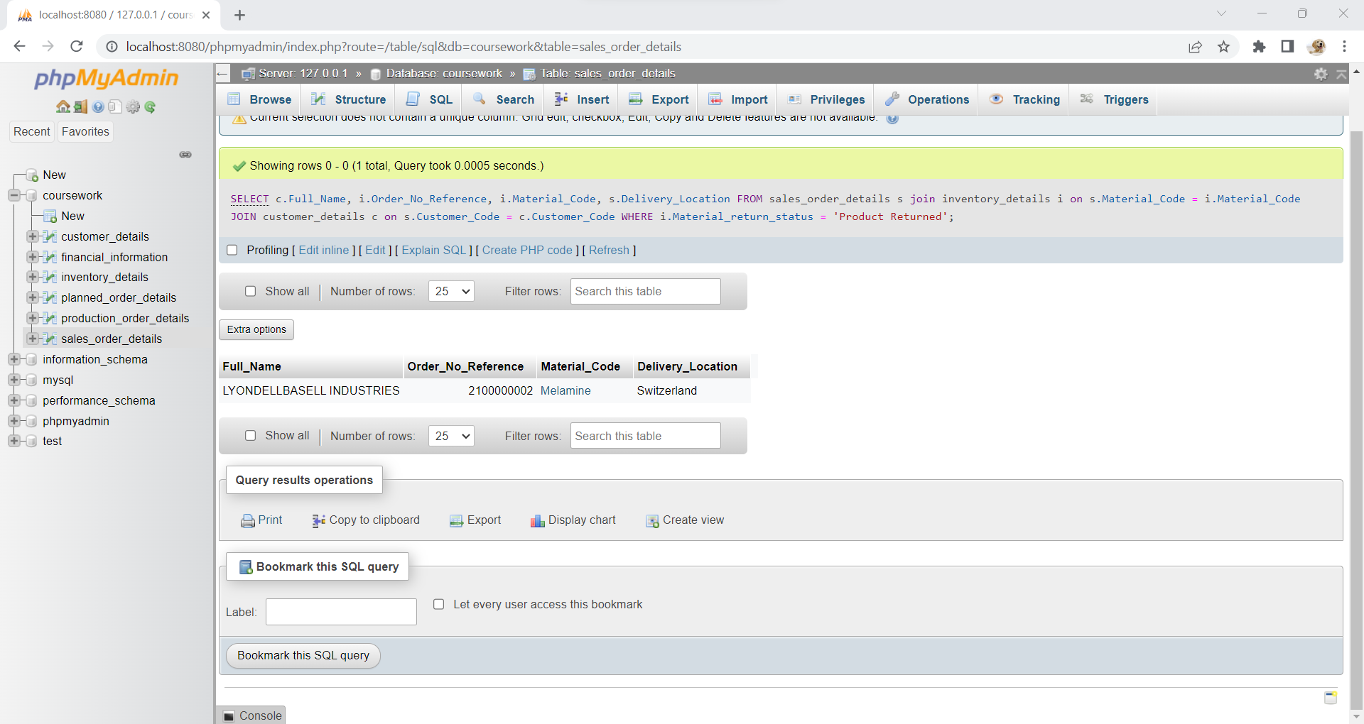

**Justification of DQL:7**

The query executed in the above operation is helps to find the orders which got returned after the delivery of the product and this is useful for them to concentrate more on the product when its undergoing production to avoid same mistake in future.